MEMORANDUM |  | 
To: | Charlie Refvem, Department of Mechanical Engineering, Cal Poly SLO
 | crefvem@calpoly.edu
From: | Antonio Ventimiglia |  | Caiden Bonney
 | ventimig@calpoly.edu |  | clbonney@calpoly.edu
Date: | 10/2/2025
RE: | Writing Hardware Drivers
In order to test the functionality of the Motor and Encoder classes, a test was administered to the Romi to satisfy the following six parameters:
  - Each motor can be enabled and disabled individually and does not start moving when enabled.
  - Each motor can spin forward and backward independently with varying speed.
  - The encoder and motor objects are paired together properly in code so that spinning a motor causes its associated encoder to count.
  - The encoders each count upward when the motors have a positive duty cycle applied, and the wheels rotate such that Romi would drive forward.
  - Each encoder position can grow in the positive and negative directions.
  - Timer reloads have no effect on the encoder speed or position.
The test comprised of measuring the position and velocity of each motor after enabling or setting a motor’s effort. A snippet of the code can be seen in Figure 1.
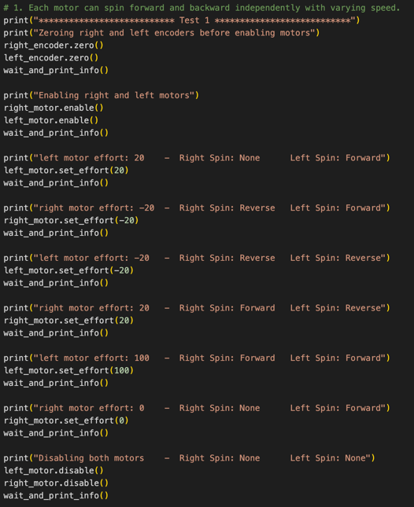
Figure 1. Snippet of code from testing
As seen in Figure 1, the “wait_and_print_info()” function is called after each action is done to the motor. This function waits some time while updating the encoder drivers and then prints the position and velocities of both encoders. The full terminal output can be seen in Figure 2.
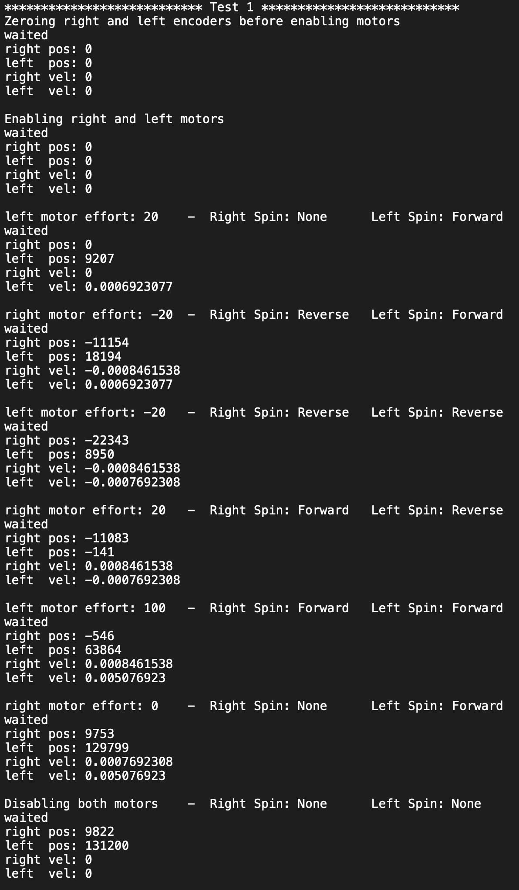
Figure 2. Terminal outputs from testing
After analyzing the terminal output from Figure 2, all the success can be observed. Since one motor can be enabled without changing the position of the other (action 3), so we satisfy parameter 1. Since the left and right motors can be set to unique effort values independently (meaning setting one motor’s effort had no effect on the other motor’s velocity) parameter 2 is satisfied. Since the position is shown to have been zero after enabling/zeroing then non-zero once the motor’s effort was set, parameter 3 is satisfied. Since the position shows an increase with a positive effort and decrease with negative effort, parameter 4 is satisfied. It was also visually confirmed that the positive effort corresponded to the forward direction. As seen in Figure 2, the position of each encoder was able to be both a positive and negative value, therefore parameter 5 is satisfied. Lastly, there are instances in which the encoders reach a position value over 65,535 which means the auto-reload set at 0xFFFF does not affect data collection, satisfying parameter 6. This quick analysis shows how the code in the python files “main.py”, “encoder.py”, and “motor.py” provide the required functionalities to the Romi device.
References:
- Refvem, C. (2025). Lab 0x01 Interrupt Callbacks and ADC Reading [Unpublished lab instructions]. Department of Mechanical Engineering, Cal Poly. Retrieved from https://canvas.calpoly.edu/courses/161863/assignments/1368600?module_item_id=4790186
- Refvem, C. (2025). Lab 0x01 Lecture 5 – Decoding Quadrature Encoders [Unpublished lecture notes]. Department of Mechanical Engineering, Cal Poly.
- Ventimiglia, A., & Bonney, C. (2025). main.py, encoder.py, motor.py [Unpublished computer software]. Department of Mechanical Engineering, Cal Poly.

